Sree Varshan

Bad Debt Prediction
A Business-Oriented Machine Learning Approach to Bad Debt Prediction
Abstract
This project presents a machine learning–based approach to predict bad debt risk using historical customer, repayment, and credit bureau data. Models were evaluated using business-focused metrics such as recall, ROC-AUC, KS, and Gini to prioritize risk ranking over accuracy. A Random Forest model with SMOTE-Tomek oversampling was selected to support risk-based segmentation and practical credit decision-making.
Content
- Problem Statement
- Objectives
- Data Collection and Integration
- Problem-Solving Approach for Bad Debt Prediction
- Project Architecture
- Data Understanding & Target Definition
- Exploratory Data Analysis (EDA)
- Data Preprocessing
- Feature Engineering
- Model Training
- Class Imbalance Handling
- Model Evaluation
- Model Interpretation & Best Model Selection
- Feature Importance Analysis
- Rank Ordering, Decile Analysis & KS Statistic
- Final Model Evaluation
- Deployment Strategy
- Conclusion
- Challenges & Limitations
- Acknowledgement
- Reference
- Declaration

Live Application:

Stream lit App

AWS EC2

Problem Statement
Credit-based businesses such as retail financing companies, lending institutions, and EMI-based sales models allow customers to purchase products or services without paying the full amount upfront. Instead, customers repay the amount over time through monthly installments or postpaid billing arrangements.
While this model helps drive sales and customer adoption, it also introduces credit risk. In practice, not all customers behave the same way—many repay their dues on time, but some delay payments or fail to repay altogether. When these outstanding amounts cannot be recovered, they turn into bad debts, directly affecting the company’s revenue, cash flow, and overall financial stability.
To manage this risk, businesses typically collect detailed customer profile information, track internal repayment behavior, and rely on external credit bureau data. Together, these data sources provide insights into a customer’s financial stability, existing credit exposure, repayment patterns, and past default history.
However, despite having access to large volumes of data, many businesses still lack an effective system to assess bad debt risk before approving credit. As a result, credit decisions are often made without a clear understanding of default probability, which leads to higher default rates and avoidable financial losses.
This project focuses on building a bad debt prediction system that uses historical customer, repayment, and credit bureau data to identify customers who are likely to default. The objective is to support better credit decision-making, reduce bad debt exposure, and strengthen overall financial risk control.

Objectives:
The objectives of this project were defined with a strong focus on both business relevance and model practicality, rather than just technical performance.
- To analyze historical customer, repayment, and credit bureau data in order to identify the key factors that clearly differentiate good customers (who repay on time) from bad customers (who default or delay payments).
- To clean and preprocess the dataset by handling missing values, outliers, and class imbalance issues, ensuring that the data used for modeling is reliable and suitable for real-world credit risk prediction.
- To build a machine learning classification model that can predict whether a customer is likely to be low risk (Good) or high risk (Bad) at the time of credit approval.
- To experiment with and compare multiple classification algorithms, including Logistic Regression, Random Forest, and XGBoost, in order to identify a model that offers the best balance between risk detection and business stability.
- To evaluate model performance using business-relevant metrics such as Accuracy, Precision, Recall, ROC–AUC, KS Statistic, and Gini Coefficient, rather than relying on accuracy alone.
- To use rank ordering and KS analysis to assess how effectively the model separates good customers from bad customers, and to explain these results in simple, non-technical terms that can be easily understood by business and operations teams.
- To use the model with a Business Rule Engine in a simple interface to support approve or reject decisions.
- To deploy the solution on a scalable cloud or web platform for easy maintenance and future growth.
- To generate clear risk-based reports to support data-driven credit and policy decisions.

Data Collection and Integration
The dataset used for this project was sourced from two separate files. The first file, Data.xlsx, contains core customer profile details along with loan and credit-related information. The second file, Additional Information.xlsx, includes supplementary customer attributes sourced from credit bureau records.
To create a unified view of each customer, both datasets were merged using a common Customer ID. This resulted in a single consolidated dataset referred to as the Credit Risk Master Table, which serves as the primary input for all analysis and modeling tasks.
After the merge, the final dataset consists of 91,879 customer records with 99 features, covering demographic, behavioral, and credit-related attributes. This consolidated dataset provides a comprehensive view of customer credit behavior and forms the foundation for building the Bad Debt (Good vs Bad) prediction model.

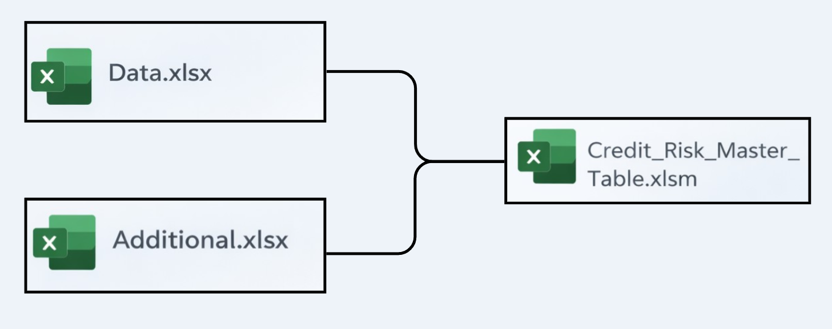

Problem-Solving Approach for Bad Debt Prediction
The business is facing financial losses due to bad debt, where some customers delay payments or default entirely. From a lending perspective, this is a major risk because credit decisions are often made before a customer’s actual repayment behavior is known.
The objective of this project was to build a predictive model that can assess whether a customer is likely to be a good or bad borrower before credit approval. The focus was not just on achieving high prediction accuracy, but on identifying risk early so that preventive actions can be taken while still approving genuinely eligible customers.
One of the key challenges in this problem is class imbalance. In the available data, around 92% of customers are good, while only about 8% are bad. Because of this imbalance, a simple model can achieve high accuracy by predicting most customers as good. However, such a model would be misleading from a business perspective, as it would fail to identify risky customers. For example, predicting every customer as good would still result in roughly 92% accuracy, but it would offer no real protection against defaults.
Due to this, accuracy alone was not treated as a reliable performance measure. Accuracy is heavily influenced by the majority class and does not reflect how well the model captures bad customers. Relying only on accuracy can lead to missed high-risk cases, increased default rates, and higher financial losses. Therefore, accuracy was used only as a supporting metric rather than the primary decision driver.
To align the model with real business requirements, clear and practical performance targets were defined. An accuracy range of 70–80% was considered acceptable for maintaining overall population stability. More importantly, recall for the bad class was targeted above 50%, as failing to identify bad customers leads directly to financial loss. In addition, ranking-based metrics such as ROC-AUC, KS statistic, and Gini coefficient were emphasized, since they measure how effectively the model orders customers by risk—an essential requirement in credit decision-making.
From a credit risk perspective, predicting a bad customer as good results in immediate financial loss, whereas predicting a good customer as bad leads to an opportunity loss, which is comparatively less severe. Based on this understanding, the model was intentionally designed to prioritize recall, even if precision was lower. This trade-off helps reduce default risk at the portfolio level rather than optimizing for superficial accuracy.
To illustrate the business impact, consider a scenario where the business faces a potential loss of ₹1 million due to bad loans. If the model is able to identify even 50–60% of risky customers in advance, the business can take preventive actions such as rejection, manual review, or stricter credit terms. This can potentially reduce losses to around ₹0.5 million, clearly showing why capturing risk is more important than achieving perfect accuracy.
The model output is not used as a simple approve-or-reject mechanism. Instead, it supports risk-based decision-making. Predicted risk is converted into a credit risk score, and customers are grouped into low, medium, and high-risk segments. Low-risk customers can be approved automatically, medium-risk customers can undergo additional checks or pricing adjustments, and high-risk customers can be rejected or manually reviewed. This approach makes the solution flexible, explainable, and scalable for real-world use.
Overall, this problem-solving approach ensures that the model aligns with real lending objectives, identifies risk before losses occur, and supports data-driven and explainable decisions. The final solution is not just a predictive model, but a business-ready system that supports credit scoring, policy rules, and portfolio-level risk management.

Project Architecture

Data Cleaning
Credit Risk Master Table
(Merged Table)
Exploratory Data Analysis

Class Imbalance
- Under sampling
- Over sampling
Feature Engineering
- Feature Creation
- Feature Selection
- Encoding
Data Pre-Processing

Deployment

Model Evaluation
- Confusion Matrix
- ROC -AUC
- KS Statistics
- Gini Coefficient

Model Training
- Logistic Regression
- XG Boost
- Cat Boost
- Random Forest

Integrating Business Rule Engine
Business Rule Engine

Data Understanding & Target Definition
The target variable in this project was defined to represent whether a customer should be classified as a Good or Bad borrower based on actual repayment behavior. This classification reflects real credit outcomes rather than theoretical risk.
Customers labeled as Good (0) are those who paid all their dues on time and do not have any recorded history of default. In contrast, customers labeled as Bad (1) are those who defaulted on payments, experienced severe or repeated payment delays, or had their loans written off.
This target definition was derived using multiple risk-related indicators, including credit score information, delinquency status, credit card payment failures, and the number of past defaults. Combining these indicators helped ensure that the target variable accurately reflects true credit risk.
After defining the target variable, the class distribution was analyzed. Out of a total of 91,822 customers, 84,341 were classified as Good, while 7,481 were classified as Bad. This confirms that the dataset is highly imbalanced, with bad customers forming a relatively small portion of the overall population.
This imbalance is important from both a modeling and business perspective. When classes are imbalanced, models tend to favor predicting the majority class, which in this case would result in most customers being labeled as good. As a result, special techniques such as resampling, class weighting, or threshold tuning become necessary. From a business standpoint, correctly identifying bad customers is far more critical than their proportion in the data, since even a small number of missed defaulters can lead to significant financial losses.

Exploratory Data Analysis (EDA)
Credit Score Check
In the dataset, there are two credit score variables coming from two different sources:
- NO_SCORE_CR21
- SCORE_CR22
To check data quality and usefulness, I used box plots to compare how these two scores behave for Good (0) and Bad (1) customers.

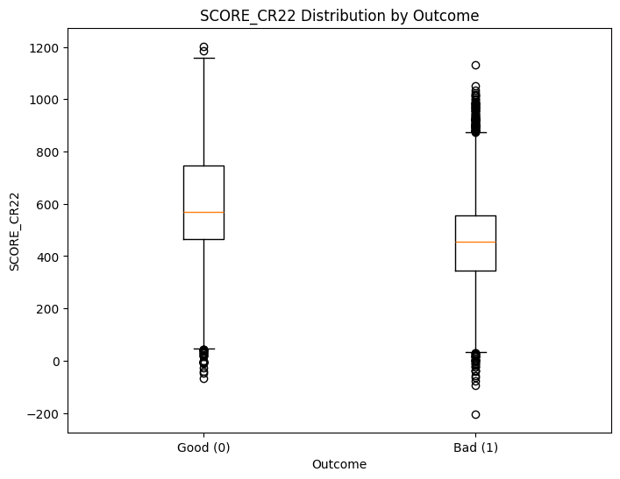
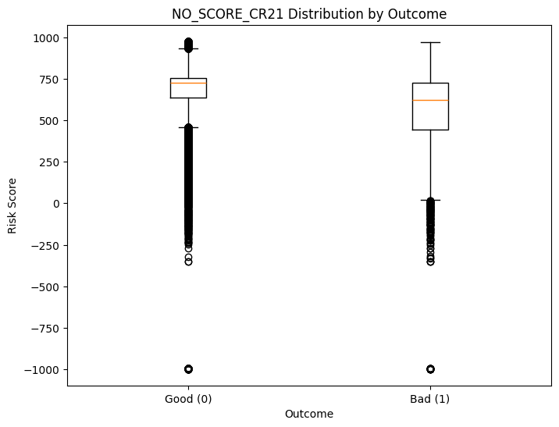

What I Observed
Credit Score & Account Features (CR21 vs CR22)
Two versions of credit-related features were available (CR21 and CR22), so I compared them using box plots across good and bad customers.
Credit Score
- NO_SCORE_CR21 contained unrealistic values (including extreme negatives such as −1000), showed a large number of outliers, and did not clearly separate good and bad customers. This indicated serious data quality issues.
- SCORE_CR22 showed a realistic score range, fewer outliers, and clear separation between good and bad customers, with bad customers generally having lower scores.
→ CR21 credit score was dropped; CR22 was retained.

Open & Closed Accounts
- CR21 account-related features showed very limited variation and did not provide meaningful differentiation between good and bad customers.
- CR22 account features displayed more intuitive patterns: bad customers typically had a higher number of open accounts, while good customers had more closed accounts, indicating healthier repayment behavior.
→ CR22 account features were retained.

Credit Card Amount
- CREDIT_CARD_AMT_CR21 contained mostly zero values and did not provide useful information for distinguishing customer risk.
- CREDIT_CARD_AMT_CR22 showed realistic values and clear differences between good and bad customers.
→ CR21 credit card amount was dropped; CR22 was retained.

Final Decision
- Only CR22 features were used for modeling, as they demonstrated cleaner data quality, better variation, and clearer separation between good and bad customers.
- Retaining CR22 features helped improve overall feature reliability and model quality.

Data Preprocessing
After understanding the data structure and quality, preprocessing steps were applied to make the dataset suitable for modeling.

Missing Values
- Missing values were handled using mean, median, or mode, depending on the nature of the feature.
- In cases where statistical imputation was not appropriate, business logic was applied to ensure that the filled values made sense from a credit risk perspective.

Outlier Treatment
Outlier treatment was applied using the Interquartile Range (IQR) method, with specific focus on the RISK_RELATIVE_CR21 feature.
- Q1, Q3, and IQR were calculated for the feature.
- Upper and lower bounds were defined using 3 × IQR to identify extreme values.
- Instead of removing outliers, values outside these bounds were capped, preserving the observation while reducing noise.
This approach helped control extreme values while retaining important risk-related information, since unusually high or low risk values can still be meaningful in credit default prediction.

Pattern Analysis
Credit Score Band Analysis (SCORE_CR22)
To better understand default behavior, credit scores were grouped into risk bands:
Risk Band | Score Range (CR22)
Very High Risk | −204 to 500
High | 501 to 607
Medium | 608 to 715
Low | 716 to 1203
Observation:
- Lower score bands showed a significantly higher default rate.
- This confirmed that SCORE_CR22 is a strong and reliable predictor of credit risk.

Correlation Analysis
Feature | SCORE_CR22 | RISK_SCORE | RISK_RELATIVE_CR21
SCORE_CR22 | 1.00 | 0.81 | 0.15
RISK_SCORE | 0.81 | 1.00 | 0.17
RISK_RELATIVE_CR21 | 0.15 | 0.17 | 1.00
Observation:
- SCORE_CR22 and RISK_SCORE showed a high correlation of 0.81, indicating strong overlap.
- Retaining both features could introduce multicollinearity into the model.
- Based on interpretability and stability, RISK_SCORE was removed, and SCORE_CR22 was retained.

Feature Engineering
Feature engineering was carried out to improve the model’s ability to capture customer stability, behavioral risk, and creditworthiness in a meaningful and interpretable way.

a) Feature Creation
New features were created to better represent customer stability and risk behavior.
- Address Stability Bucket
The variable NO_ADDRESS_AT_MONTHS was grouped into meaningful buckets
(<6 months, 6–12 months, 12–36 months, >36 months) to capture address stability in a simplified and interpretable form.
- Life Instability Flag
A combined instability flag was created using both address duration and employment duration.
Customers with both address tenure and job tenure less than 12 months were marked as high instability, as frequent changes in residence and employment often indicate higher credit risk.

b) Feature Selection
Weight of Evidence (WoE) & Information Value (IV)
Feature selection was performed using Weight of Evidence (WoE) and Information Value (IV) to ensure stability, interpretability, and alignment with credit risk modeling practices.
- WoE was used to capture the relationship between each feature and default risk.
- IV was used to quantify the predictive strength of each feature.
IV Thresholds Used
- < 0.02 → Not predictive
- 0.02 – 0.10 → Weak
- 0.10 – 0.30 → Medium
- 0.30 – 0.50 → Strong
- > 0.50 → Very strong (checked carefully for potential leakage)
Only features with IV > 0.04 were retained. This helped preserve key risk drivers—such as credit score, bureau defaults, delinquency indicators, and payment failure patterns—while removing weak or noisy variables.
This approach resulted in a stable, interpretable, and credit-risk-aligned feature set, suitable for both modeling and deployment.

Dropped Features (Noise Reduction)
Certain features were removed to improve model robustness, interpretability, and ease of deployment.
Reasons for Dropping
- High correlation with other predictors
- Redundant business-rule-based variables
- Raw fields replaced by engineered features
- High noise with low predictive value
Key Dropped Features
- RISK_SCORE → Internal business-rule score; highly correlated with SCORE_CR22, leading to redundancy.
- RISK_RELATIVE_CR21 → Derived from an internal risk score; did not provide independent predictive value despite appearing strong.
- CD_STS_RESIDENTIAL → Redundant with the RESIDENTIAL feature.
- DEFAULT_CNT_12M_CR22 → Overlaps with cumulative default count variables.
- SCORE_BAND_CR22 → Derived from SCORE_CR22; raw score retained for finer granularity.
- Enquiry-related features → Removed due to IV values below 0.04, indicating very weak predictive contribution.

c) Feature Scaling & Encoding
Feature Scaling
Numerical features were scaled using standardization (zero mean and unit variance) to ensure consistent treatment across models.
- Scaling improved learning for Logistic Regression and XGBoost.
- For Random Forest, no significant improvement was observed, which is expected since tree-based models rely on splits rather than feature magnitude.
Scaling was still applied to:
- Maintain a consistent preprocessing pipeline
- Support multiple model experiments
- Ensure deployment readiness
- Allow easy model switching and comparison

Encoding
Categorical variables were converted into numerical format using one-hot encoding (pd.get_dummies).
- Binary indicator columns were created for each category.
- One reference category was dropped to avoid multicollinearity.
This ensured that the final dataset was fully numerical, model-ready, and consistent across training, evaluation, and deployment stages.

Final Summary
These feature engineering and preprocessing steps ensured that the dataset was stable, interpretable, and suitable for real-world credit risk modeling, while following best practices across different machine learning algorithms.

Model Training
- Random Forest
- XGBoost
- CatBoost
- Logistic Regression

Attempt 1: Class Imbalance Handling (Under sampling)
Used Algorithm | Training Data |  |  |  |  | Test Data |  |  |  |  | Is it Overfitting?
Used Algorithm | Accuracy | Precision | Recall | F1- Score | Auc - Roc | Accuracy | Precision | Recall | F1- Score | Auc - Roc | Is it Overfitting?
Logistic | 0.67 | 0.67 | 0.65 | 0.66 | 0.74 | 0.68 | 0.15 | 0.37 | 0.25 | 0.75 | Yes
Cat Boost | 0.71 | 0.72 | 0.68 | 0.71 | 0.79 | 0.70 | 0.16 | 0.65 | 0.76 | 0.75 | Yes
XG Boost | 0.76 | 0.78 | 0.72 | 0.76 | 0.84 | 0.69 | 0.15 | 0.66 | 0.76 | 0.74 | No
Random Forest | 0.68 | 0.70 | 0.65 | 0.69 | 0.76 | 0.70 | 0.16 | 0.66 | 0.77 | 0.75 | Yes

Attempt 2: Class Imbalance Handling Using SMOTE-Tomek Oversampling
Used Algorithm | Training Data |  |  |  |  | Test Data |  |  |  |  | Is it Overfitting?
Used Algorithm | Accuracy | Precision | Recall | F1- Score | Auc - Roc | Accuracy | Precision | Recall | F1- Score | Auc - Roc | Is it Overfitting?
Logistic | 0.61 | 0.57 | 0.97 | 0.57 | 0.78 | 0.32 | 0.09 | 0.91 | 0.40 | 0.69 | Yes
Cat Boost | 0.70 | 0.63 | 0.98 | 0.67 | 0.88 | 0.45 | 0.10 | 0.82 | 0.56 | 0.70 | Yes
XG Boost | 0.78 | 0.78 | 0.77 | 0.78 | 0.88 | 0.76 | 0.15 | 0.47 | 0.81 | 0.70 | No
Random Forest | 0.74 | 0.74 | 0.76 | 0.74 | 0.84 | 0.72 | 0.16 | 0.61 | 0.78 | 0.74 | No

Model Interpretation & Best Model Selection
Multiple models were evaluated using both under sampling and SMOTE-Tomek oversampling techniques. Model performance was compared using business-relevant metrics such as Recall, Accuracy, and ROC-AUC to identify a solution that balances risk detection with operational stability.
Overall Interpretation
- Models trained using under sampling showed acceptable ROC-AUC values; however, the reduced sample size led to less stable model behavior.
- SMOTE-Tomek oversampling improved class balance and enabled better learning of default (bad customer) patterns.
- Some models, particularly Logistic Regression and CatBoost, became overly recall-focused after oversampling, resulting in very low precision and reduced practical usability.
- Therefore, the selection objective focused on identifying a balanced, stable, and deployable model rather than maximizing recall alone.
Best Model Selection
Based on the overall evaluation, Random Forest with SMOTE-Tomek oversampling was selected as the final model.
Rationale for Selection
- Balanced Risk Identification:
The model achieves a recall of 0.61, capturing a meaningful proportion of risky customers without being overly aggressive.
- Stable Population Performance:
An accuracy of 0.72 meets the minimum stability requirement for portfolio-level predictions.
- Good Discriminatory Power:
A ROC-AUC of 0.74 indicates effective separation between good and bad customers.
- Generalization Capability:
Limited performance gap between training and test data suggests controlled overfitting.
- Operational Practicality:
Compared to recall-heavy alternatives, this model avoids excessive rejection of good customers, making it suitable for real-world credit approval processes.
Final Conclusion
Random Forest with SMOTE-Tomek oversampling was selected as the final model as it offers the best balance between risk detection, stability, and business usability. This makes it a reliable and practical choice for deployment in a real-world credit risk environment.

Feature Importance
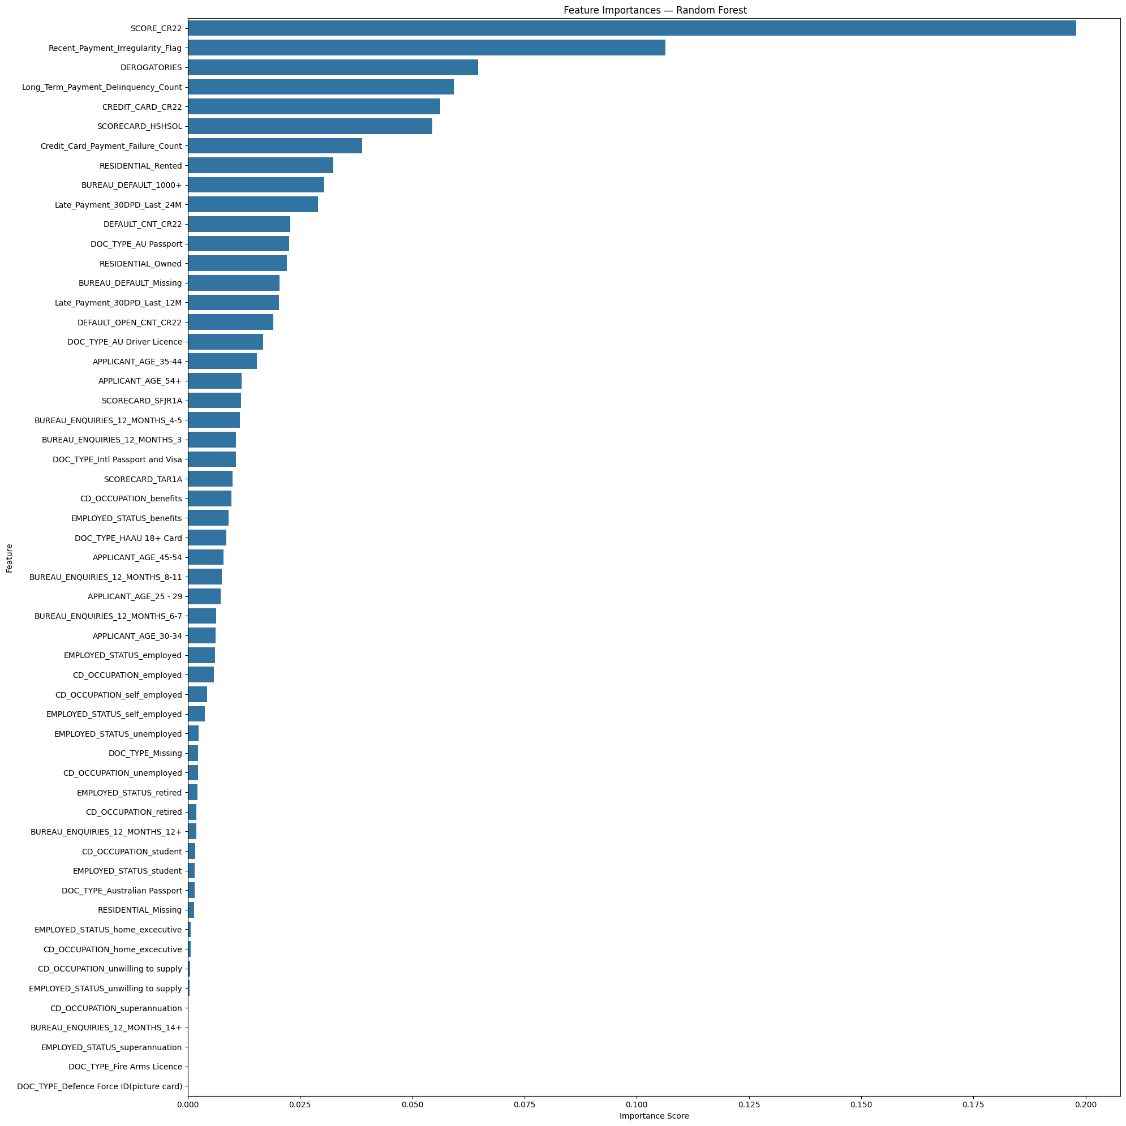

- SCORE_CR22 is the most important driver, showing that credit score is the strongest indicator of default risk.
- Recent_Payment_Irregularity_Flag highlights that recent missed or delayed payments sharply increase bad debt risk.
- DEROGATORIES confirms that negative credit bureau remarks strongly signal higher default probability.
- Long_Term_Payment_Delinquency_Count indicates that repeated historical delinquencies are a major risk factor.
- CREDIT_CARD_CR22 reflects that higher or stressed credit card exposure is associated with increased risk.
- SCORECARD_HSSOL captures internal scorecard signals that complement bureau-based credit scores.
- Credit_Card_Payment_Failure_Count shows that failed card payments are early warning signs of financial stress.
- Residential status (Rented vs Owned) suggests stability matters—rented customers show relatively higher risk.
- Bureau default indicators (counts and missing flags) help identify both known defaulters and risky data gaps.
- Demographic and enquiry features contribute marginally, acting as secondary signals rather than core risk drivers.

ROC Curve – Random Forest
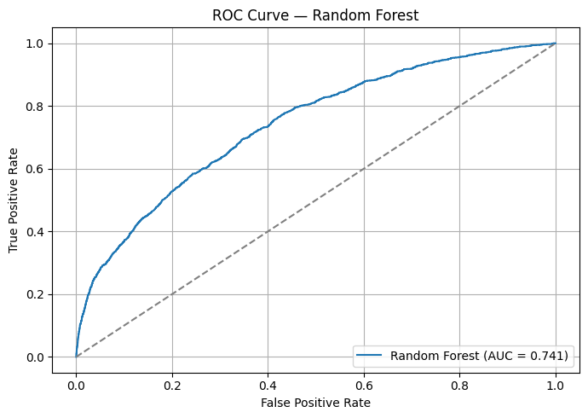

Rank Ordering, Decile Analysis & KS Statistic
Rank Ordering Assessment
Rank ordering evaluates whether the model correctly sorts customers from low risk to high risk based on predicted default probability.
In Bad Debt Prediction, correct ranking is more important than a single yes/no prediction, as it supports risk-based decisioning.
To assess rank ordering, a decile-based analysis was used.

Use of Deciles for Rank Ordering
Customers were grouped into deciles based on their predicted probability of default.
This allows clear observation of how risk is distributed across the population.

A good credit risk model is expected to show:
- Lower bad rates in lower deciles
- Higher bad rates in higher deciles
- A monotonic increase in risk from the first to the last decile
The observed pattern confirms that the model ranks customers correctly by risk level.

What Is a Decile?
A decile divides the customer population into 10 equal-sized groups based on predicted risk.
- Decile 0 → Lowest-risk customers
- Decile 9 → Highest-risk customers
- Each decile represents 10% of the total population, ordered from safest to riskiest

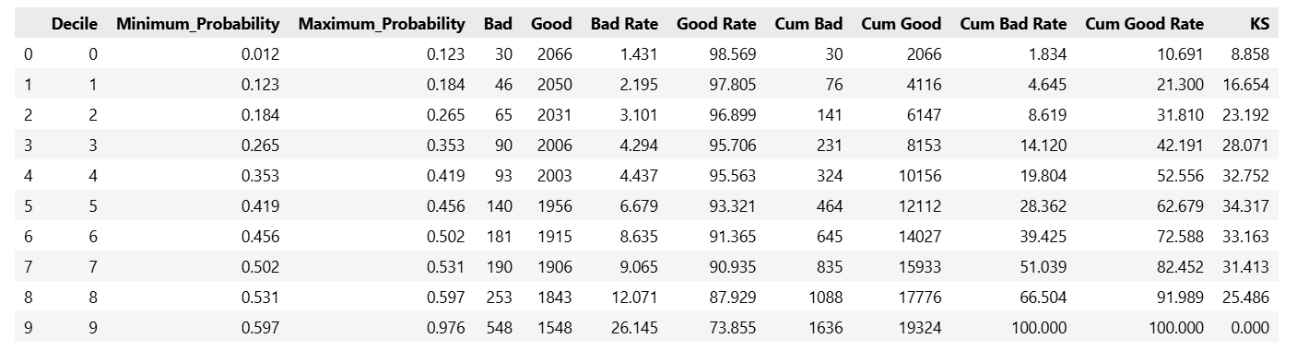
Decile Rank Ordering Table

Observation:
Decile & KS Interpretation
Customers are ranked from lowest risk (Decile 0) to highest risk (Decile 9) based on predicted default probability.
- The bad rate increases consistently from 1.43% in Decile 0 to 26.15% in Decile 9, confirming strong rank ordering.
- Higher-risk customers are correctly concentrated in the upper deciles, while lower deciles contain mostly good customers.
- The KS statistic peaks at ~34, indicating good separation between good and bad customers.
- This level of KS falls within the “Good” performance range for credit risk models.

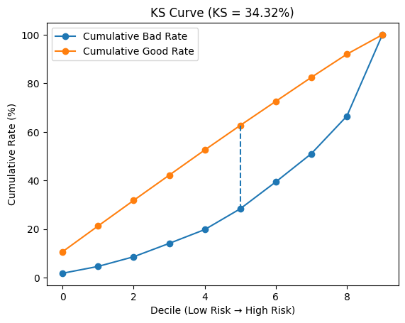

Conclusion:
The model demonstrates strong ranking power and clear risk differentiation, making it suitable for cutoff setting, risk banding, and bad debt control.

Gini Coefficient
The Gini Coefficient is used to assess how well the model ranks customers from low risk to high risk. In credit risk analysis, the ability to correctly order customers by risk is critical, making Gini a key evaluation metric.
What Gini Represents
Gini reflects how clearly the model separates:
- Good customers who repay on time
- Bad customers who default or delay payments
A higher Gini value indicates that risky customers are consistently assigned higher risk scores, while safer customers receive lower scores.
Gini is derived from ROC-AUC using the formula:
Gini = 2 × ROC-AUC − 1

Model Result
- Gini Coefficient = 0.48
This result indicates that the model has good ranking capability and is able to clearly distinguish between good and bad customers.
Interpretation
Gini Range | Meaning
< 0.30 | Weak
0.30 – 0.40 | Acceptable
0.40 – 0.55 | Good
> 0.55 | Very strong

With a Gini score of 0.48, the model falls within the “Good” performance range based on standard credit risk benchmarks.

Business Relevance
A strong Gini score confirms that the model’s risk ranking is reliable, supporting:
- Risk-based approval cut-offs
- Creation of risk bands and deciles
- Portfolio-level risk control
- Alignment with credit policy decisions

Although precision is relatively low—which is expected in highly imbalanced credit datasets—the Gini score confirms that the model remains effective, reliable, and suitable for real-world credit decisioning.

Final Model Evaluation
To ensure the model is practical for real-world credit decision-making, it was evaluated using key risk, ranking, and stability metrics. These metrics focus on how well the model identifies risky customers while maintaining overall portfolio stability.
Metric | Value | Interpretation
ROC–AUC | ~0.74–0.75 | Good separation between good and bad customers
KS Statistic | ~34 | Strong risk separation across customer groups
Gini Coefficient | ~0.48 | Good and reliable risk ranking
Recall (Bad) | > 50% | Identifies a meaningful share of risky customers
Accuracy | > 70% | Stable performance at the population level

Key Observations
- The model shows strong ability to separate good and bad customers using risk-based metrics.
- Risky customers are identified early, helping reduce potential bad debt losses.
- Ranking quality is consistent, making the model suitable for cut-off setting and risk banding.
- The balance between recall and accuracy ensures risk control without hurting approvals too much.
- Model performance is stable across datasets, indicating good reliability after deployment.
- Overall, the model supports practical, explainable, and policy-aligned credit decisions.

Deployment
When the system goes live, the machine learning model first labels each customer as Good or Bad based on data patterns.
This prediction is not used directly to approve or reject a loan.
Instead, the result is passed to a Business Rule Engine (BRE), which makes the final credit decision.

How the Model and BRE Work Together
- The model provides an initial Good / Bad risk signal
- The BRE checks this against credit score limits, delinquency history, and policy rules
- Based on these checks, the customer is tagged as Low Risk, Medium Risk, High Risk, or Reject
Even if the model marks a customer as Good, the BRE can still downgrade or reject the case if strong risk indicators are present.
Why This Approach Is Used
- It reduces the chance of approving risky customers
- It adds a clear business control layer over the model
- It keeps decisions consistent and easy to explain
- It helps control bad debt in real-world scenarios

The model highlights potential risk, and the BRE ensures decisions follow business rules.
Together, they create a reliable, explainable, and production-ready credit decision system.

Challenges:
- Handling a highly imbalanced dataset while improving recall for bad customers without over-rejecting good ones.
- Ensuring clear risk separation using ranking metrics like KS, Gini, and decile analysis instead of accuracy alone.
- Understanding and cleaning complex credit data with multiple noisy and redundant features.
- Balancing model performance with business stability and portfolio impact.
- Translating model outputs into a business-oriented decision system using risk bands and a rule engine.

Conclusion
This project successfully demonstrates how data-driven credit risk modeling can be used to proactively control bad debt in credit-based businesses. By combining customer profile data, repayment behavior, and external credit bureau information, a comprehensive and realistic view of customer risk was created.
Rather than focusing only on prediction accuracy, the project emphasized business-critical objectives such as identifying risky customers early, maintaining portfolio stability, and enabling risk-based decision-making. Key challenges such as severe class imbalance, noisy credit bureau variables, and redundant features were addressed using appropriate preprocessing, feature engineering, and model evaluation techniques aligned with industry practices.
Multiple machine learning models were evaluated under different imbalance-handling strategies. Based on recall, ROC–AUC, KS statistic, Gini coefficient, and overall stability, Random Forest with SMOTE-Tomek oversampling was selected as the final model. The model demonstrated good ranking power (KS ≈ 34, Gini ≈ 0.48) and was able to identify a meaningful proportion of bad customers while maintaining acceptable accuracy at the portfolio level.
Importantly, the solution was designed as a business-ready system, not just a predictive model. The model output is integrated with a Business Rule Engine (BRE), allowing final credit decisions to follow policy rules, risk thresholds, and operational controls. This approach improves explainability, reduces unintended risk exposure, and supports scalable deployment in real-world lending environments.
Overall, this project shows how machine learning, when combined with strong domain understanding and business logic, can significantly enhance credit decision-making, reduce bad debt risk, and support sustainable growth for lending institutions.

Acknowledgements
I would like to acknowledge the learning resources, online documentation, and reference materials that supported my understanding of credit risk modeling concepts, machine learning techniques, and evaluation metrics used in this project. These resources helped strengthen both the technical and business-oriented approach of the solution.

Reference
- Stack Overflow – Community discussions and code examples used to support implementation logic
(https://stackoverflow.com/questions)
- Kolmogorov–Smirnov Statistic Explained (Credit Risk Context) — Towards Data Science
https://towardsdatascience.com/kolmogorov-smirnov-statistic-explained-measuring-model-power-in-credit-risk-modeling/
- K–S Score for Model Evaluation — Medium
https://medium.com/@kstarun/k-s-score-for-model-evaluation-5339f0a5c705
- Beyond ROC–AUC and KS: Gini Coefficient Explained Simply — Towards Data Science
https://towardsdatascience.com/beyond-roc-auc-and-ks-gini-coefficient-explained-simply/

Declaration
I hereby declare that this project is my original work, developed for learning and demonstration purposes. Any external references used were for conceptual understanding only.

